Supplementary Information
Figure A1. Main data layers used to determine communities at risk from wildfire and BAFT: (a) forest disturbances including fire⁹⁵and harvest⁹⁶ from 1990 to 2020; (b) aboveground biomass (odt/ha) in 2020, including branches, foliage, bark, and stemwood from trees in forest stands⁵¹; (c) wildland human interface (WHI)⁵²; d) current homogeneous fire regime zones⁴⁹ and e) future homogeneous fire regime zones⁴⁹ Each map also includes the 33 communities at risk from wildfire. Data sources are provided in Table.A2.

(e)

(b)

(a)

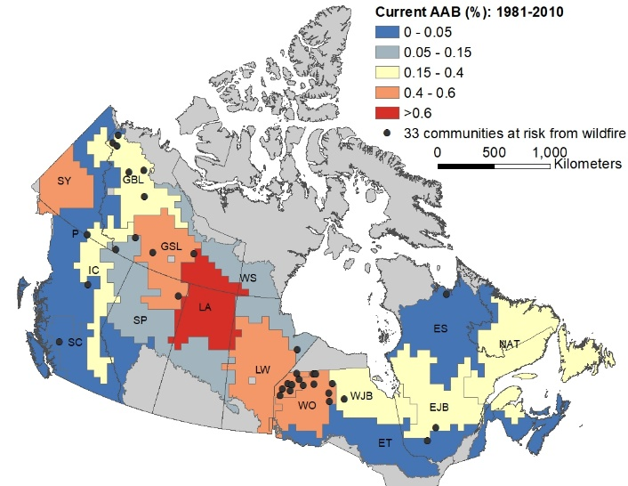
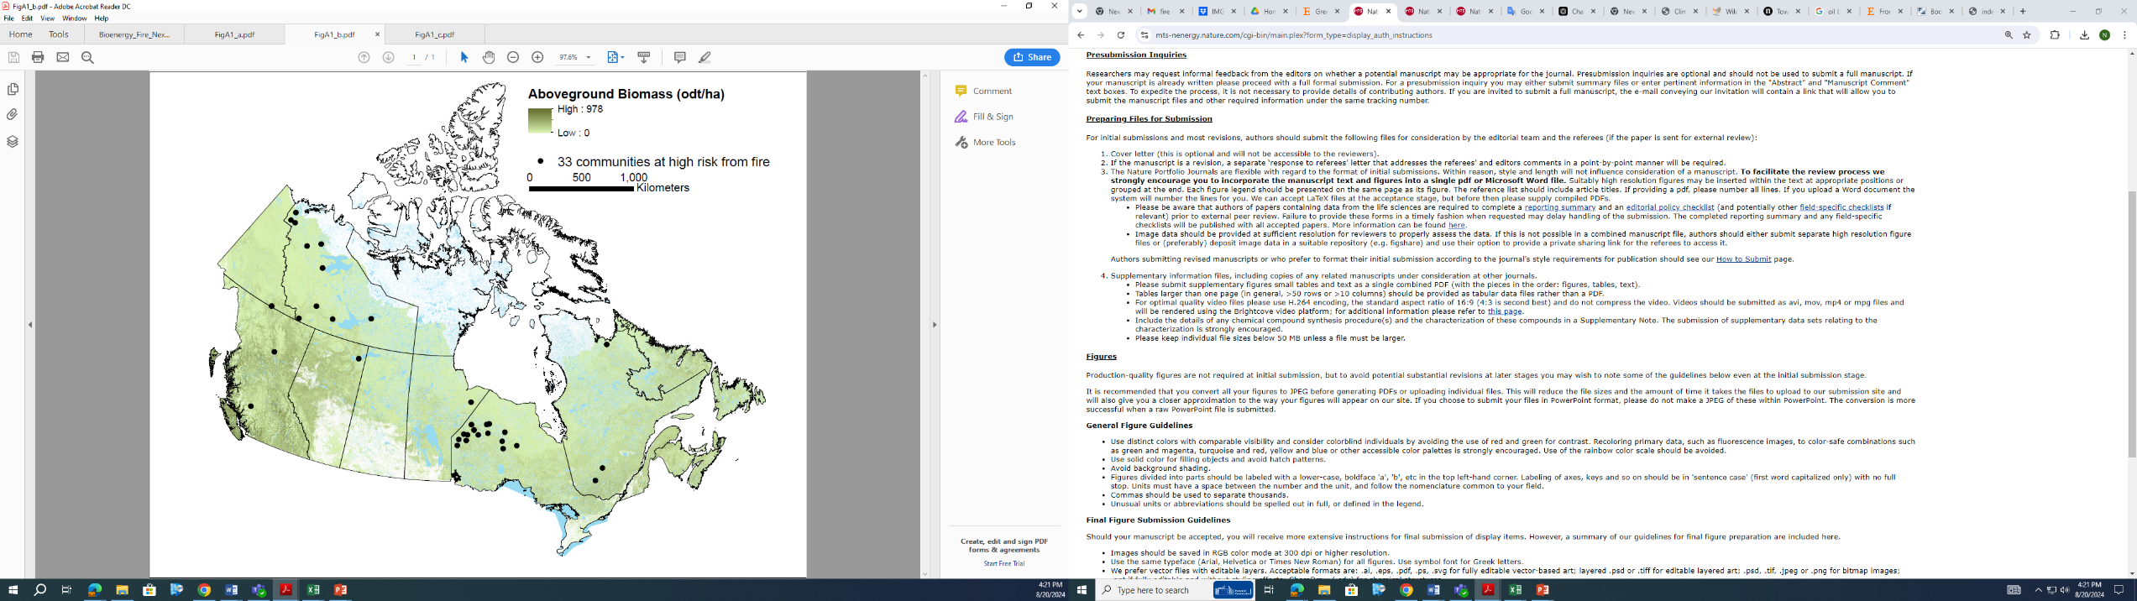
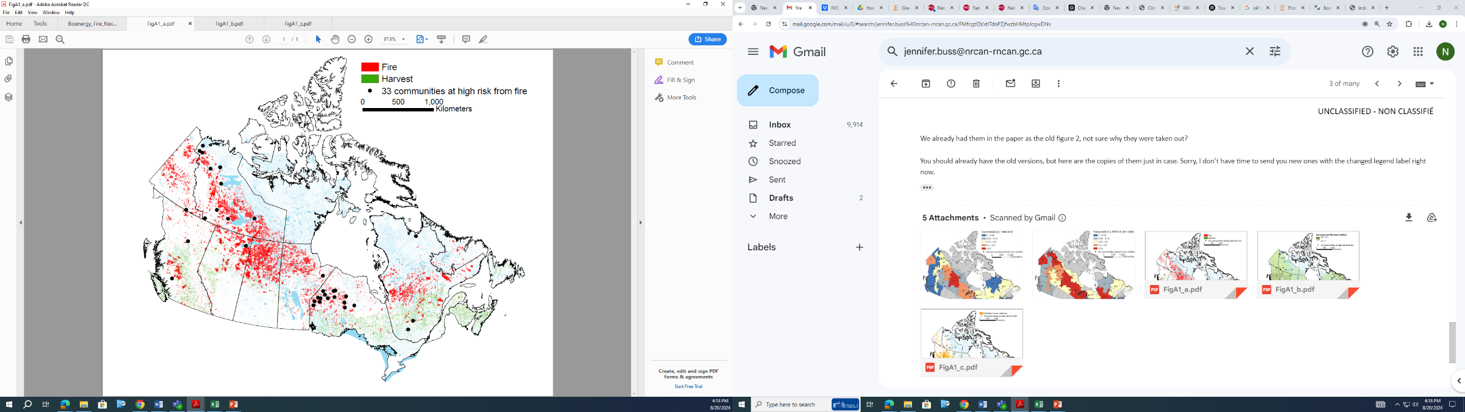
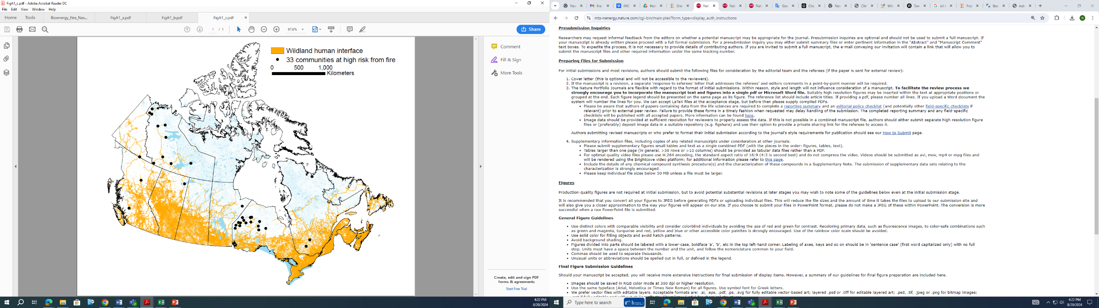  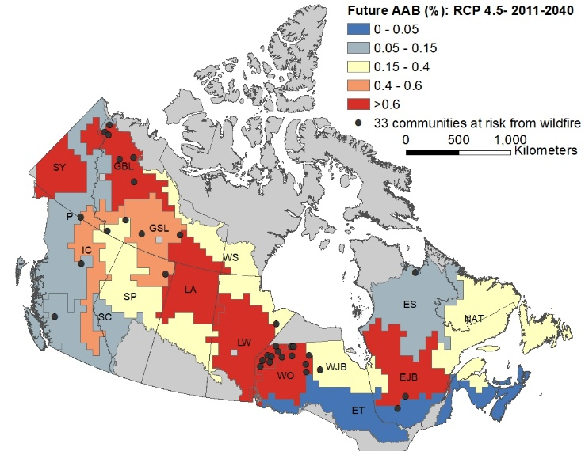  (c) | (d)
Figure A2: The relationship between annual fossil fuel generation (energy demand) and population including the equation used to estimate the missing energy demands for 8 communities. Annual energy demand and population values are from the Remote Communities Energy Database³⁸– see Table.1

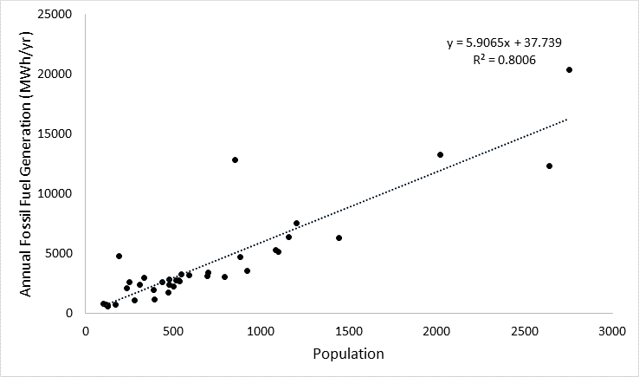

Table A1: The seven FireSmart Disciplines (from FireSmart Canada²⁰).
FireSmart Discipline | Description
Education | Neighbourhood, group, or individual learning more about the threat of wildfire and how to mitigate it.
Emergency Planning | Wildfire prevention and mitigation plans and emergency response and preparedness.
Vegetation Management | Fuel removal, reduction, or conversion to less flammable species to mitigate the impact of wildfire and decrease wildfire intensity.
Legislation | Legislation, bylaws, plans, policies, and development standards that impact the building and planning of neighbourhoods and maintenance of FireSmart neighbourhoods.
Development | Development standards to reduce the impact of wildfire and potential damage on a neighbourhood.
Interagency Cooperation | Strong relationships between elected officials, neighbourhood planners, developers, government, industry, and residents to ensure public education, and a collaborative approach to FireSmart practices.
Cross Training | Brings emergency response organizations together across jurisdictional boundaries to ensure preparedness in case of wildfire.

Table A2: Data sources of the main spatial layers used in our analysis. See figureA1
Data | Citation | Link and Sources
Remote Communities Energy Database (2021) | Government of Canada. Remote Communities Energy Database. | https://open.canada.ca/data/en/dataset/0e76433c-7aeb-46dc-a019-11db10ee28dd
Homogenous Fire Regime Zones (2020) | Boulanger, Y. et al. A refinement of models projecting future Canadian fire regimes using homogeneous fire regime zones. Can. J. For. Res. 44, 365-376 (2014). | https://open.canada.ca/data/en/dataset/779f9b2d-d010-4ddc-b3b3-57a9ac7631b2
National Burned Area Composite (1990-2020) | Hall, R.J. et al. Generating annual estimates of forest fire disturbance in Canada: the National Burned Area Composite. Int. J. Wildland Fire. doi:10.1071/WF19201 (2020). | https://cwfis.cfs.nrcan.gc.ca/datamart/metadata/nbac
Canada Landsat Disturbance (1990-2020) | Guindon, L. et al. Canada Landsat Disturbance (CanLaD): a Canada-wide Landsat-based 30-m resolution product of fire and harvest detection and attribution since 1984. Natural Resources Canada. Canadian forest Service | https://open.canada.ca/data/en/dataset/660b7c6a-cdec-4c02-90c7-d63e91825c42
Aboveground biomass (2020) | Guindon, L. et al. A new approach for Spatializing the Canadian National Forest Inventory (SCANFI) using Landsat dense time series. Can. J. For. Res. (2024). | https://open.canada.ca/data/en/dataset/18e6a919-53fd-41ce-b4e2-44a9707c52dc
Wildland Human Interface (2020) | Johnston, L.M. & Flannigan, M.D. Mapping Canadian wildland fire interface areas. Int. J. Wildland Fire 27, 1-14 (2018). | Mapping Canadian wildland fire interface areas. - Open Science and Data Platform

Table A3: Community groupings and data used in the heat map (see Fig.3). The code developed for the analyses is provide below.
Community | Province | Undisturbed forest within 10 km (%) | Total biomass within 10km available for fuel treatment (%) | Current AAB (%) | Future AAB (%) | Theoretical percentage of area at risk to be treated annually (%) (raw biomass) * | Heat map priority group
Clova | QC | 91 | 54 | 0.31 | 0.82 | 0.01 | 1
Fort Simpson | NT | 100 | 60 | 0.15 | 0.23 | 0.22 | 1
Watson Lake | YT | 98 | 58 | 0.32 | 0.59 | 0.18 | 1
Deer Lake | ON | 97 | 25 | 0.52 | 1.84 | 0.23 | 2
Keewaywin | ON | 92 | 27 | 0.52 | 1.84 | 0.19 | 2
Muskrat Dam Lake | ON | 100 | 32 | 0.52 | 1.84 | 0.05 | 2
North Spirit Lake | ON | 96 | 30 | 0.52 | 1.84 | 0.09 | 2
Poplar Hill | ON | 100 | 12 | 0.52 | 1.84 | 0.27 | 2
Sachigo Lake | ON | 99 | 15 | 0.52 | 1.84 | 0.37 | 2
Sandy Lake | ON | 93 | 20 | 0.52 | 1.84 | 0.72 | 2
Aklavik | NT | 100 | 5 | 0.36 | 0.69 | 2.37 | 3
Colville Lake | NT | 100 | 13 | 0.36 | 0.69 | 0.22 | 3
Délı̨nę | NT | 100 | 24 | 0.36 | 0.69 | 0.80 | 3
Fort Chipewyan | AB | 97 | 37 | 0.59 | 0.55 | 0.67 | 3
Fort Good Hope | NT | 100 | 22 | 0.36 | 0.69 | 0.85 | 3
Fort Hope | ON | 92 | 20 | 0.50 | 0.61 | 0.68 | 3
Fort McPherson | NT | 98 | 22 | 0.36 | 0.69 | 0.45 | 3
Fort Providence | NT | 100 | 40 | 0.59 | 0.55 | 0.11 | 3
Kingfisher Lake | ON | 96 | 38 | 0.50 | 0.61 | 0.10 | 3
Kitchenuhmaykoosib | ON | 90 | 27 | 0.50 | 0.61 | 0.70 | 3
Łutselk'e | NT | 100 | 32 | 0.59 | 0.55 | 0.35 | 3
Neskantaga | ON | 100 | 22 | 0.50 | 0.61 | 0.12 | 3
Tsiigehtchic | NT | 99 | 29 | 0.36 | 0.69 | 0.12 | 3
Wapekeka Reserve 1 | ON | 95 | 26 | 0.50 | 0.61 | 0.21 | 3
Weagamow Lake | ON | 99 | 27 | 0.50 | 0.61 | 0.30 | 3
Webequie | ON | 99 | 21 | 0.50 | 0.61 | 0.43 | 3
Fort Liard | NT | 100 | 18 | 0.15 | 0.23 | 0.09 | 4
Kuujjuaq | QC | 100 | 26 | 0.04 | 0.07 | 1.92 | 4
Lac-Rapide | QC | 95 | 25 | 0.02 | 0.03 | 0.16 | 4
Ogoki | ON | 95 | 17 | 0.15 | 0.23 | 0.41 | 4
Tsay Keh Dene | BC | 95 | 26 | 0.02 | 0.07 | 0.04 | 4
Xeni Gwet'in First Nation | BC | 100 | 23 | 0.04 | 0.06 | 0.04 | 4
Shamattawa | MB | 97 | 2 | 0.11 | 0.23 | 7.03 | 5
*Values have been rounded to 2 decimal places

#Figure 3 clustering and heatmap R code

library(ggplot2)
library(rlang)
library(plotly)
library(heatmaply)
library(dendextend)
library(parameters)
library(NbClust)
library(mclust)
library(see)
library(factoextra)
library(dplyr)
library(gridExtra)

bio <- read.csv("heatmap_jan_25.csv",encoding="UTF-8")

bio_matrix <- as.data.frame(bio[,3:6]) %>%
dplyr::rename("FTA"=Percent.Harvest,
"Current AAB"=Current.FR,
"Future AAB"=Future.FR)

rownames(bio_matrix) <- paste(bio$Community,bio$Prov,sep=" ")
# calculates the cophenetic correlation between the distance matrix and the
# cophenetic distance of the hclust obj
# highest optim = best clustering model for a distance matrix
bio_d <- dist(bio_matrix,method="euclidean")
dend_expend(bio_d) # centroid

# finds optimal numbers of clusters based on consensus of many methods
n_clust <- n_clusters(bio_matrix,package=c("easystats","NbClust","mclust",standardize=TRUE, # standardizes the dataset before clustering
distance_method="euclidean",
h_clust_method="centroid", # selected based on previous step
method="hclust")) # same results for pam, hclust, kmeans etc
n_clust # 7 methods out of 29 recommend 5 clusters/groups

figheatmap$x$layout$xaxis$showticklabels <- FALSE ## remove tick labels for dendrogram
figheatmap$x$layout$xaxis2$showticklabels <- TRUE ## keep tick labels for columns

figheatmap <- heatmaply(normalize(bio_matrix),dist_method="euclidean",hclust_method="centroid",k_row=5,
colors=cool_warm(3), ylab="Communities",grid_gap=0.2,row_dend_left=TRUE,dendrogram='row',
plot_method="plotly",fontsize_row=16,fontsize_col=16,colorbar_xpos=0,colorbar_ypos=0.35,
subplot_widths=c(0.5,0.5)) %>%
colorbar(tickfont = list(size = 16))

figheatmap

